negative hypergeometric distribution

Intro

It is a special case of beta-binomial distribution with parameter

$$a$$ = $$r$$

$$b$$ = $$N−K+r+1$$

Parameter

$$N$$ population size

$$K$$ number of success in population.

$$r$$ number of failure in population.

$$k$$ number of success in observations.

PDF

$$f\left(k;N,K,r\right)$$

= $$\frac{C\left(k,k+r−1\right)}{C\left(K,N\right)}⋅C\left(K−k,N−r−k\right)$$

where

$$C\left(K,N\right)$$

= $${}_{N}C_{K}$$



CDF

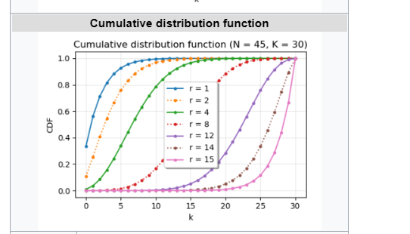

Expected Value

$$E\left[X\right]$$

= $$\frac{rK}{N−K+1}$$

Proof: (wrong proof)

For correct proof, see the following figure.

= $$integral\left(i⋅\operatorname{Pr}\left(X==i\right),i=0,i=K\right)$$

= $$sigma\left(i⋅\operatorname{Pr}\left(X==i\right),i=0,i=K\right)$$

= $$sigma\left(i⋅\frac{C\left(i,i+r−1\right)}{C\left(K,N\right)}⋅C\left(K−i,N−r−i\right),i=0,i=K\right)$$

(since it is defined only for integer in negative hypergeometric distribution)

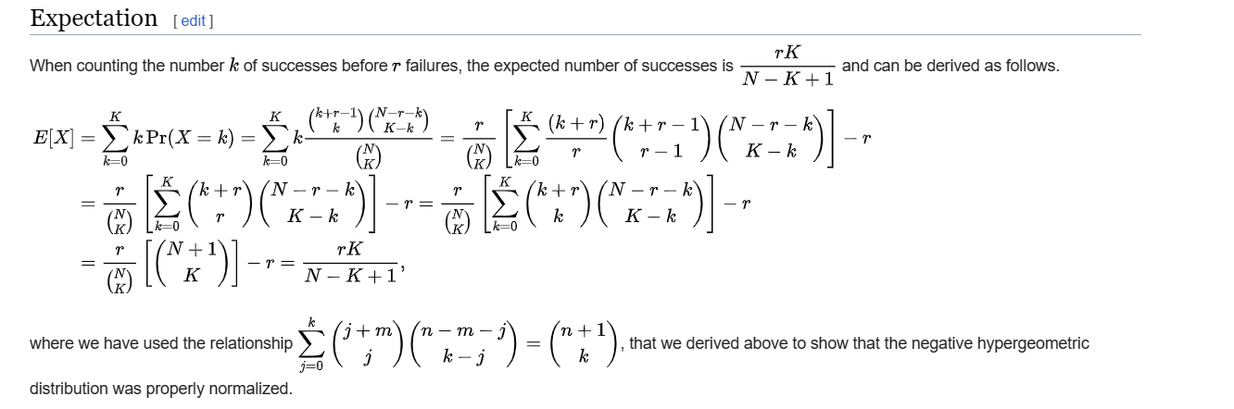

Variance

$$Var\left[X\right]$$

= $$\frac{rK\left(N+1\right)\left(N−K−r+1\right)}{{\left(N−K+1\right)}^{2}\left(N−K+2\right)}$$

Proof:

The proof on the following figure.

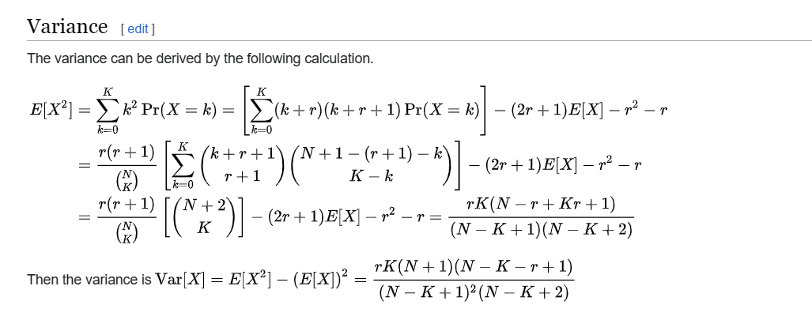

Ref

[Negative hypergeometric distribution - Wikipedia](https://en.wikipedia.org/wiki/Negative_hypergeometric_distribution)